**Bahria University,**

**Karachi Campus**



**LAB EXPERIMENT NO.**

**08**

**LIST OF TASKS**

|  |  |
| --- | --- |
| TASK NO | OBJECTIVE |
| **01** | **Explore HTOP, including its options. Attach outputs for the same.** |
| **02** | **Write a multithreaded C program for performing summation of numbers.** |
| 03 | Write a program which make 4 threads. Each thread will print one table out of [5678] up to 1000. |

**Submitted On:**

____________

**(Date: DD/MM/YY)**

**Task No. 1:** Explore HTOP, including its options. Attach outputs for the same.

**Solution:**

HTOP command in Linux System is a command line utility that allows the user to interactively monitor the system’s vital resources or server’s processes in real time.

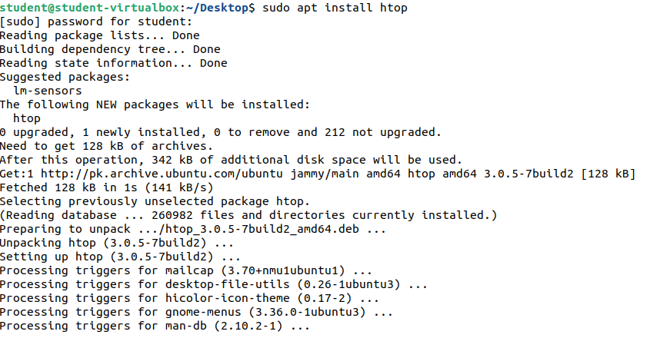

**Output:**

* Htop -h ( Help )

* F5 Tree

**Task No. 2:** Write a multithreaded C program for performing summation of numbers.

**Solution:**

#include <stdio.h>

#include <unistd.h>

#include <pthread.h>

int sum; int array[2];

void *AddNumbers(void *arg);

void main() {

pthread_t thread1;

printf("Enter Number 1: \n"); scanf("%d", &array[0]);

printf("Enter Numnber 2: \n"); scanf("%d", &array[1]);

pthread_create(&thread1, NULL, AddNumbers, array); pthread_join(thread1, NULL); }

void *AddNumbers (void *arg) {

int * arr = (int *) arg; int n1= arr[0];

int n2= arr[1]; sum = n1 + n2;

printf("\nSum of both numbers = %d \n", sum); pthread_exit(0); }

**Output:**

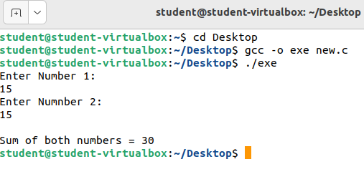

**Task No. 3:** Write a program which make 4 threads. Each thread will print one table out of [5678] up to 1000.

**Solution:**

#include <stdio.h>

#include <unistd.h>

#include <pthread.h>

int num = 5; int array[3];

void * Tables(void *arg);

void main() {

pthread_t thread1; pthread_t thread2;

pthread_t thread3; pthread_t thread4;

for (int i = 0; i < 4; i++) {

array[i] = num; num++; }

num = 5;

pthread_create(&thread1, NULL, Tables, array); pthread_join(thread1, NULL);

num++; pthread_create(&thread2, NULL, Tables, array);

pthread_join(thread2, NULL); num++;

pthread_create(&thread3, NULL, Tables, array); pthread_join(thread3, NULL);

num++; pthread_create(&thread4, NULL, Tables, array);

pthread_join(thread4, NULL); }

void *Tables(void *arg) {

for (int i = 1; i <= 1000; i++) {

switch (num){

case 5: printf("%d x %d = %d\n", array[0], i, array[0] * i); break;

case 6: printf("%d x %d = %d\n", array[1], i, array[1] * i); break;

case 7: printf("%d x %d = %d\n", array[2], i, array[2] * i); break;

case 8: printf("%d x %d = %d\n", array[3], i, array[3] * i); break; } }

pthread_exit(0); }

**Output:**

